STANDARD Referral Form (Standard for Supported Contact)
Neutral Ground Child Contact Centre  Tel/Fax: 020 83041770 (Mon - Fri) Tel: 020 8310 0727 (Sat) |  |  |  |  |  |  | 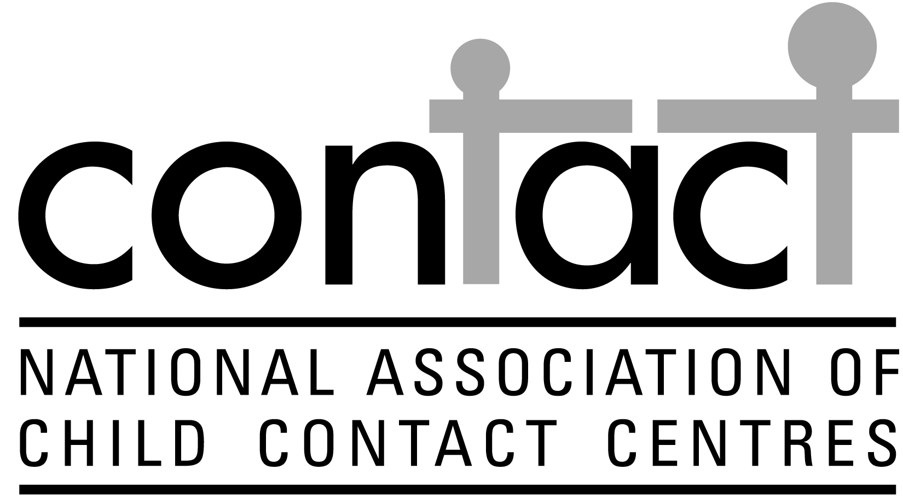
Wherever possible this form needs to be seen and completed by both parties’ solicitors and any other professionals involved with the family.  Contact cannot commence until this form has been completed in full and received by the Centre Coordinator. All information will be treated in the strictest confidence. Please print clearly. If typed and returned by e-mail, the ‘yes’ or ‘no’ can be deleted as appropriate. It is accepted as signed if returned from an office e-mail address from a named person. |  | Office use only
 |  | Referral received
 |  | Date of pre-visit
 |  | Date of first contact
 |  | Dates reviewed
 |  | Contact ended
1. Children
Name(s) |  |  | Age |  | Date of birth |  |  |  |  | Boy (B), Girl (G)
2. Adult requesting contact
Name:
Relationship to child(ren):
Does this person have legal parental responsibility? (please circle) |  |  |  |  |  |  |  | Yes |  |  | No
Length of time since: | a) They met children
 | b) They lived with children
Address:
Postcode: |  | Telephone:
Solicitor’s name: |  |  |  | Solicitor’s ref:
Name of practice:
Address:
Postcode:
Email: |  | Telephone:
3. Adult with whom the child(ren) reside
Name:
Relationship to child(ren):
Address:
Postcode: |  | Telephone:
Solicitor’s name: |  |  |  | Solicitor’s ref
Name of practice:
Address:
Postcode:
Email: |  | Telephone:
4. Referrer
Name: |  | Profession:
Address:
Postcode:
Email: |  | Telephone:
5. CAFCASS, Contact Orders & Contact
a. Has there been any CAFCASS involvement? (please circle) |  |  |  |  |  |  |  |  |  | Yes |  | No
b. Is there an allocated CAFCASS officer? (please circle) |  |  |  |  |  |  |  |  |  | Yes |  | No
If ‘Yes’, please give details: Name:
Name of CAFCASS office:
Address:
Postcode: |  | Telephone:
c. When and where did contact last take place?
d. Is there a court order relating to the contact? (please circle) |  |  |  |  |  |  |  |  |  | Yes |  | No
If ‘Yes’, please either send a copy or indicate what it specifies. [Please include a copy if possible as knowing exact
wording can be vital to avoid unnecessary disputes within the Centre]
e. What other court orders have been made in relation to the child(ren) and when?
f. Can the child(ren) be taken out of the Centre? (please circle) |  |  |  |  |  |  |  |  |  | Yes |  | No
g. What is the next court date (if any)?

6. Arrival at the Child Contact Centre
a. Are the parents willing to meet? (please circle) |  |  | Yes |  | No
b. Will the adult with whom the child(ren) reside be bringing them to and collecting them from the Centre? (please circle) |  |  | Yes |  | No
If ‘No’, who will be bringing / collecting the child(ren)?
c. What is the preferred date of first contact at the Centre?
d. How frequently will contact take place?
e. For how long will each visit last?
f. Names of other people allowed to participate in contact at the Centre:
Name | Relationship to child
7. Information Relating to Safety of the Child
a. Are there or have there been sexual / child abuse allegations made in this family? (please circle). If ‘Yes’, please give details (over page) |  |  | Yes |  | No
b. Is this family known to Social Services? (please circle)  If ‘Yes’, please give details (over page)  If ‘Yes’, please give details (over page) |  |  | Yes |  | No
c. Has any person who will be involved in the contact ever been convicted of an offence against a child(ren)? (please circle) |  |  | Yes |  | No
If ‘Yes’, please give details
d. Has there been or is there likely to be a risk of abduction? (please circle) |  |  | Yes |  | No
If ‘Yes’, are procedures in place for holding passports, etc. (please circle) |  |  | Yes |  | No
e. Please give details of any allegations, undertakings, injunctions or convictions relating to violence involving either party, their respective families or the children.
8. Health & Medical Requirements
- Do any of the children have any illness, allergy, impairment, special needs  or medical requirements? (please circle) If ‘Yes’, please give details |  |  | Yes |  | No
- Do any of the adults involved suffer from long-term physical / mental illness  or an impairment? (please circle) If ‘Yes’, please give details |  |  | Yes |  | No
9. Additional Information
a. What language is spoken at home?
b. Is an interpreter required? (please circle) |  | Yes |  | No
If ‘Yes’, please give details of the interpreter to be used (include name and organisation if any)
c. Has this family ever used another Child Contact Centre? (please circle) |  | Yes |  | No
If ‘Yes, please give details (this Centre may be contacted).
d. Additional background information (Please use a separate sheet if necessary).
I have explained the rules of the Child Contact Centre to my client and given them a copy of the Centre’s leaflet / guidelines. This form has been completed accurately and to the best of my knowledge.
Signed: ………………………………………………………………..… Date: ………………………………………
Please return this form to Neutral Ground via fax: 020 83041770
Or via email to contact@neutralground.info

We offer contact within the times 11 a.m. to 4.00 p.m. alternate Saturdays. The dates for 2012 are on our website http://www.neutralground.info/

